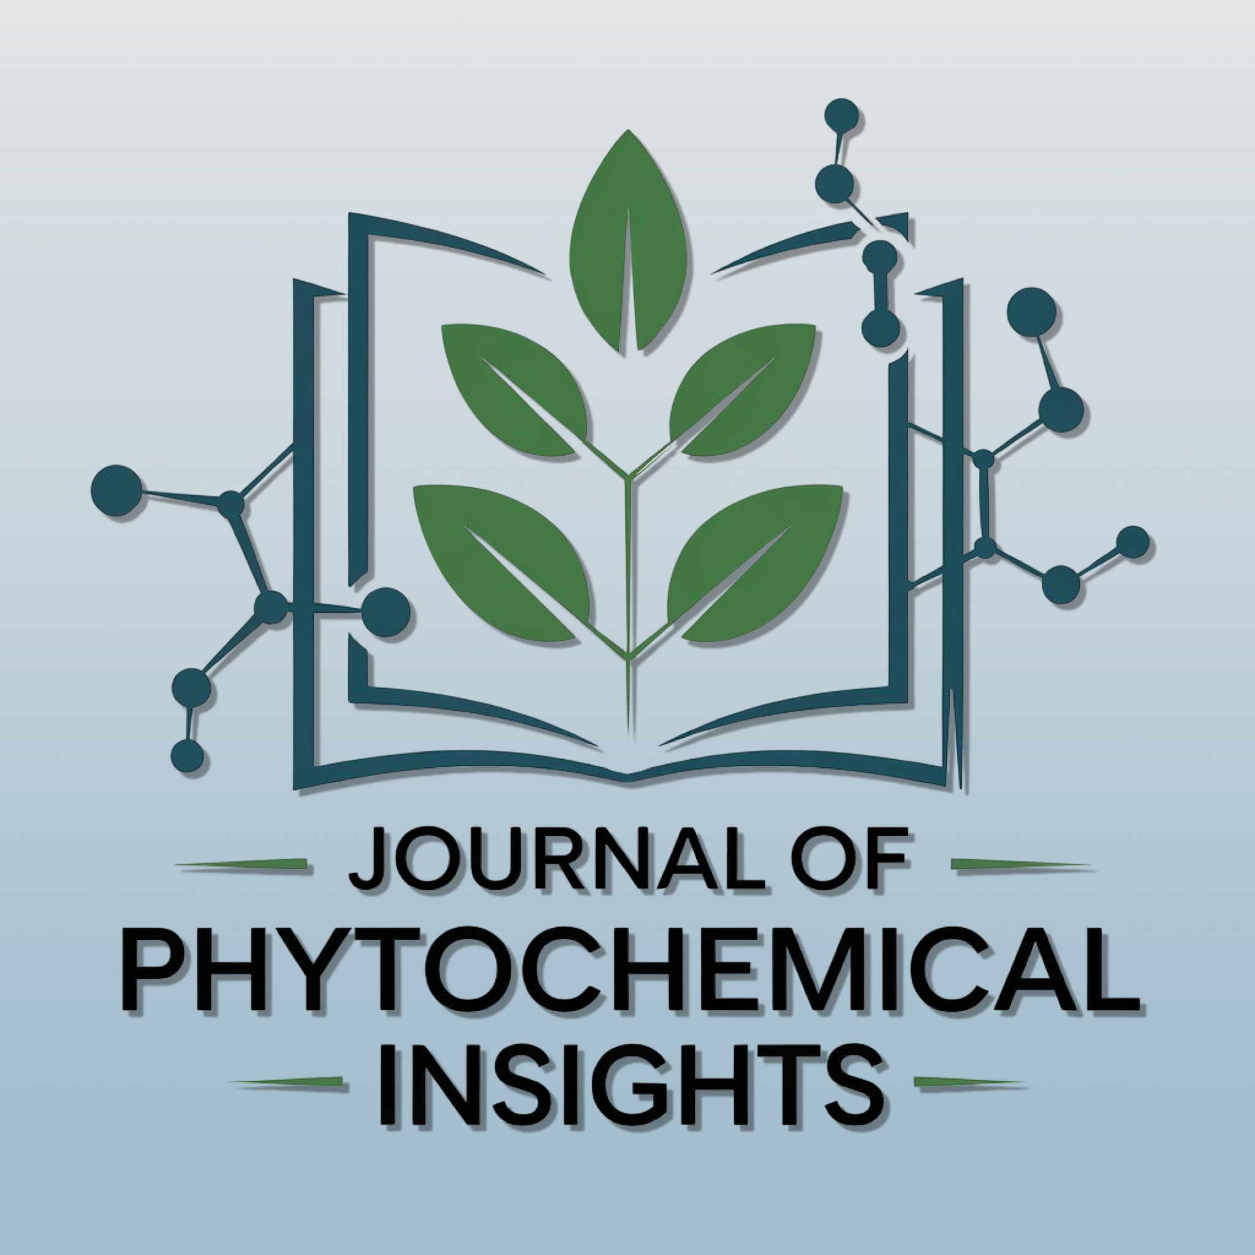

Journal of Phytochemical Insights (JPCI)
COPYRIGHT & LICENSE AGREEMENT FORM
eISSN: 3080-0005 | DOI Prefix: 10.71193
Published by BioLuster Research Center Ltd.

Copyright and Open Access Policy
Journal of Phytochemical Insights (JPCI) publishes all accepted articles as Open Access under the Creative Commons Attribution 4.0 International (CC BY 4.0) License. Authors retain the copyright to their work while granting JPCI a non-exclusive license to publish, reproduce, distribute, archive, index, and preserve the article in any medium. Third parties may share and adapt the work provided appropriate credit is given to the original authors and the journal, a link to the CC BY 4.0 license is provided, and any changes are indicated.

Before Signing
☐ The manuscript is original and has not been published previously.
☐ The manuscript is not under consideration elsewhere.
☐ All authors have approved the submission and this agreement.
☐ Permissions have been obtained for all third-party copyrighted material.
☐ Any conflicts of interest and funding sources have been disclosed.

Manuscript Information
Manuscript ID: _________________________________
Manuscript Title: _________________________________________________

Declaration by the Corresponding Author
I, as the corresponding author, declare that I am authorized by all co-authors to sign this Copyright & License Agreement on their behalf. I confirm that all authors have read and approved the final manuscript, agree to its submission and publication, and consent to publication under the CC BY 4.0 license. I further confirm that the manuscript does not infringe the copyright or other intellectual property rights of any third party.

Corresponding Author Signature
Full Name
Institution
Email
Signature
Date
Official Use (optional)

Editorial Office Use Only
Date Received
Reviewed By
Decision | ☐ Accepted ☐ Revision Required
Remarks

